

*Geophysical Research Letters*

Supporting Information for

**Geography and morphology affect the ice duration dynamics of northern hemisphere lakes worldwide**

C. P. K. Warne1, K. S. McCann2, N. Rooney1, Kévin Cazelles2 and M. M. Guzzo2

1School of Environmental Sciences, University of Guelph, 50 Stone Road East, Guelph, Ontario, Canada, N1G 2W1.

2Department of Integrative Biology, University of Guelph, 50 Stone Road East, Guelph, Ontario, Canada, N1G 2W1.

**Contents of this file**

Figures S1 – S6

Tables S1, S2

**Additional Supporting Information (Files uploaded separately)**

Captions for Figures S1 – S6

Captions for Tables S1 and S2

**Introduction**

Figure S1 is a map that indicates the global position, relative sizes (surface area) and elevation of lakes included in our analyses. Figure S2 includes a set of scatterplots that investigate any patterns between the length of lake time series data and our multiple regression predictor variables as well as between time series length and ice duration trend and ice duration variance. Figure S3 is a Beta coefficient plot that shows the relative contribution of each predictor variable to changes in ice duration for a much smaller sample size of lakes which had overlapping ice duration data between 1950 and 2000 (n=27 lakes). Figure S4 is a simple plot of ice duration values and air temperature values for the 27 lakes that had overlapping ice duration data between 1950 and 2000. Figure S5 is a histogram that shows the ice duration slope values of lakes plotted versus their ice duration time series length (in years). Figure 6 is a global surface air temperature anomaly map for the approximate time period of study (1900-2015) created using GISS data from NASA. Table S1 includes results pertaining to the proportion of lakes losing or gaining ice duration based on the length of lake time series data. Table S2 provides summary data for the characteristics, locations and calculated values pertaining to each northern hemisphere lake included in our analyses (n=220). Much of this data is derived from the Global Lakes and Rivers Ice Phenology (GLRIP) dataset, curated by the Lake Ice Analysis Group (LIAG) which we accessed in January 2019. Some additional lake-specific information that was not part of GLRIP but was included in supporting information from Sharma et al. (2019) was used and compiled here as well.

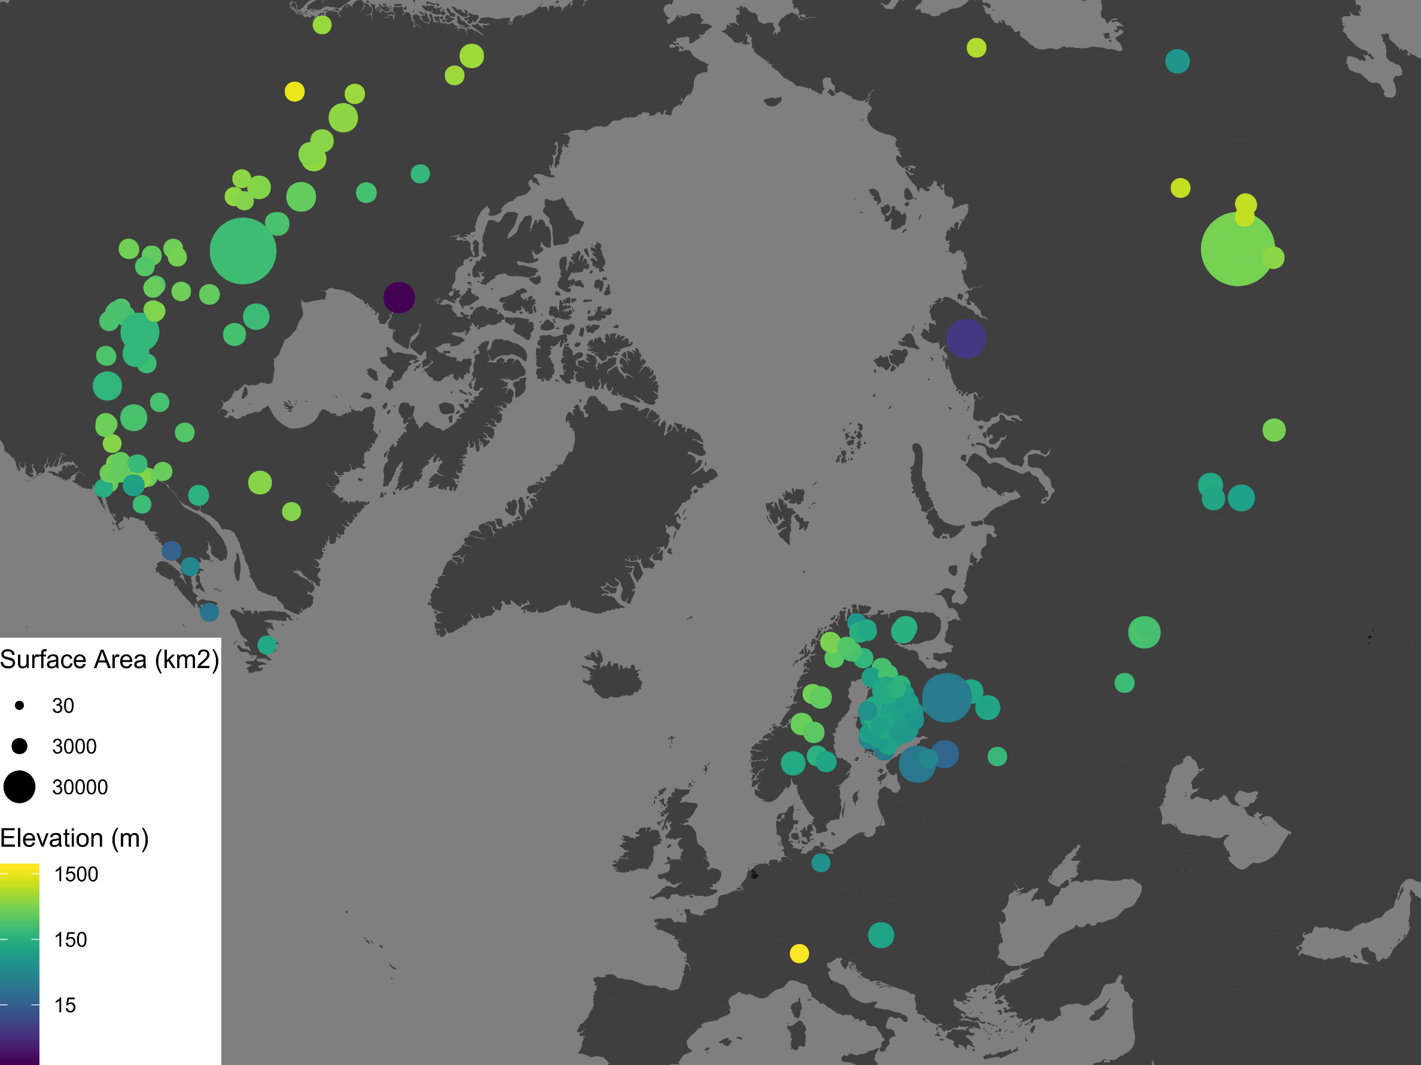

**Figure S1.** Map summarizing the global position, elevation (m above sea level) and surface area (km2) for the full data set of 220 lakes considered in analyses.

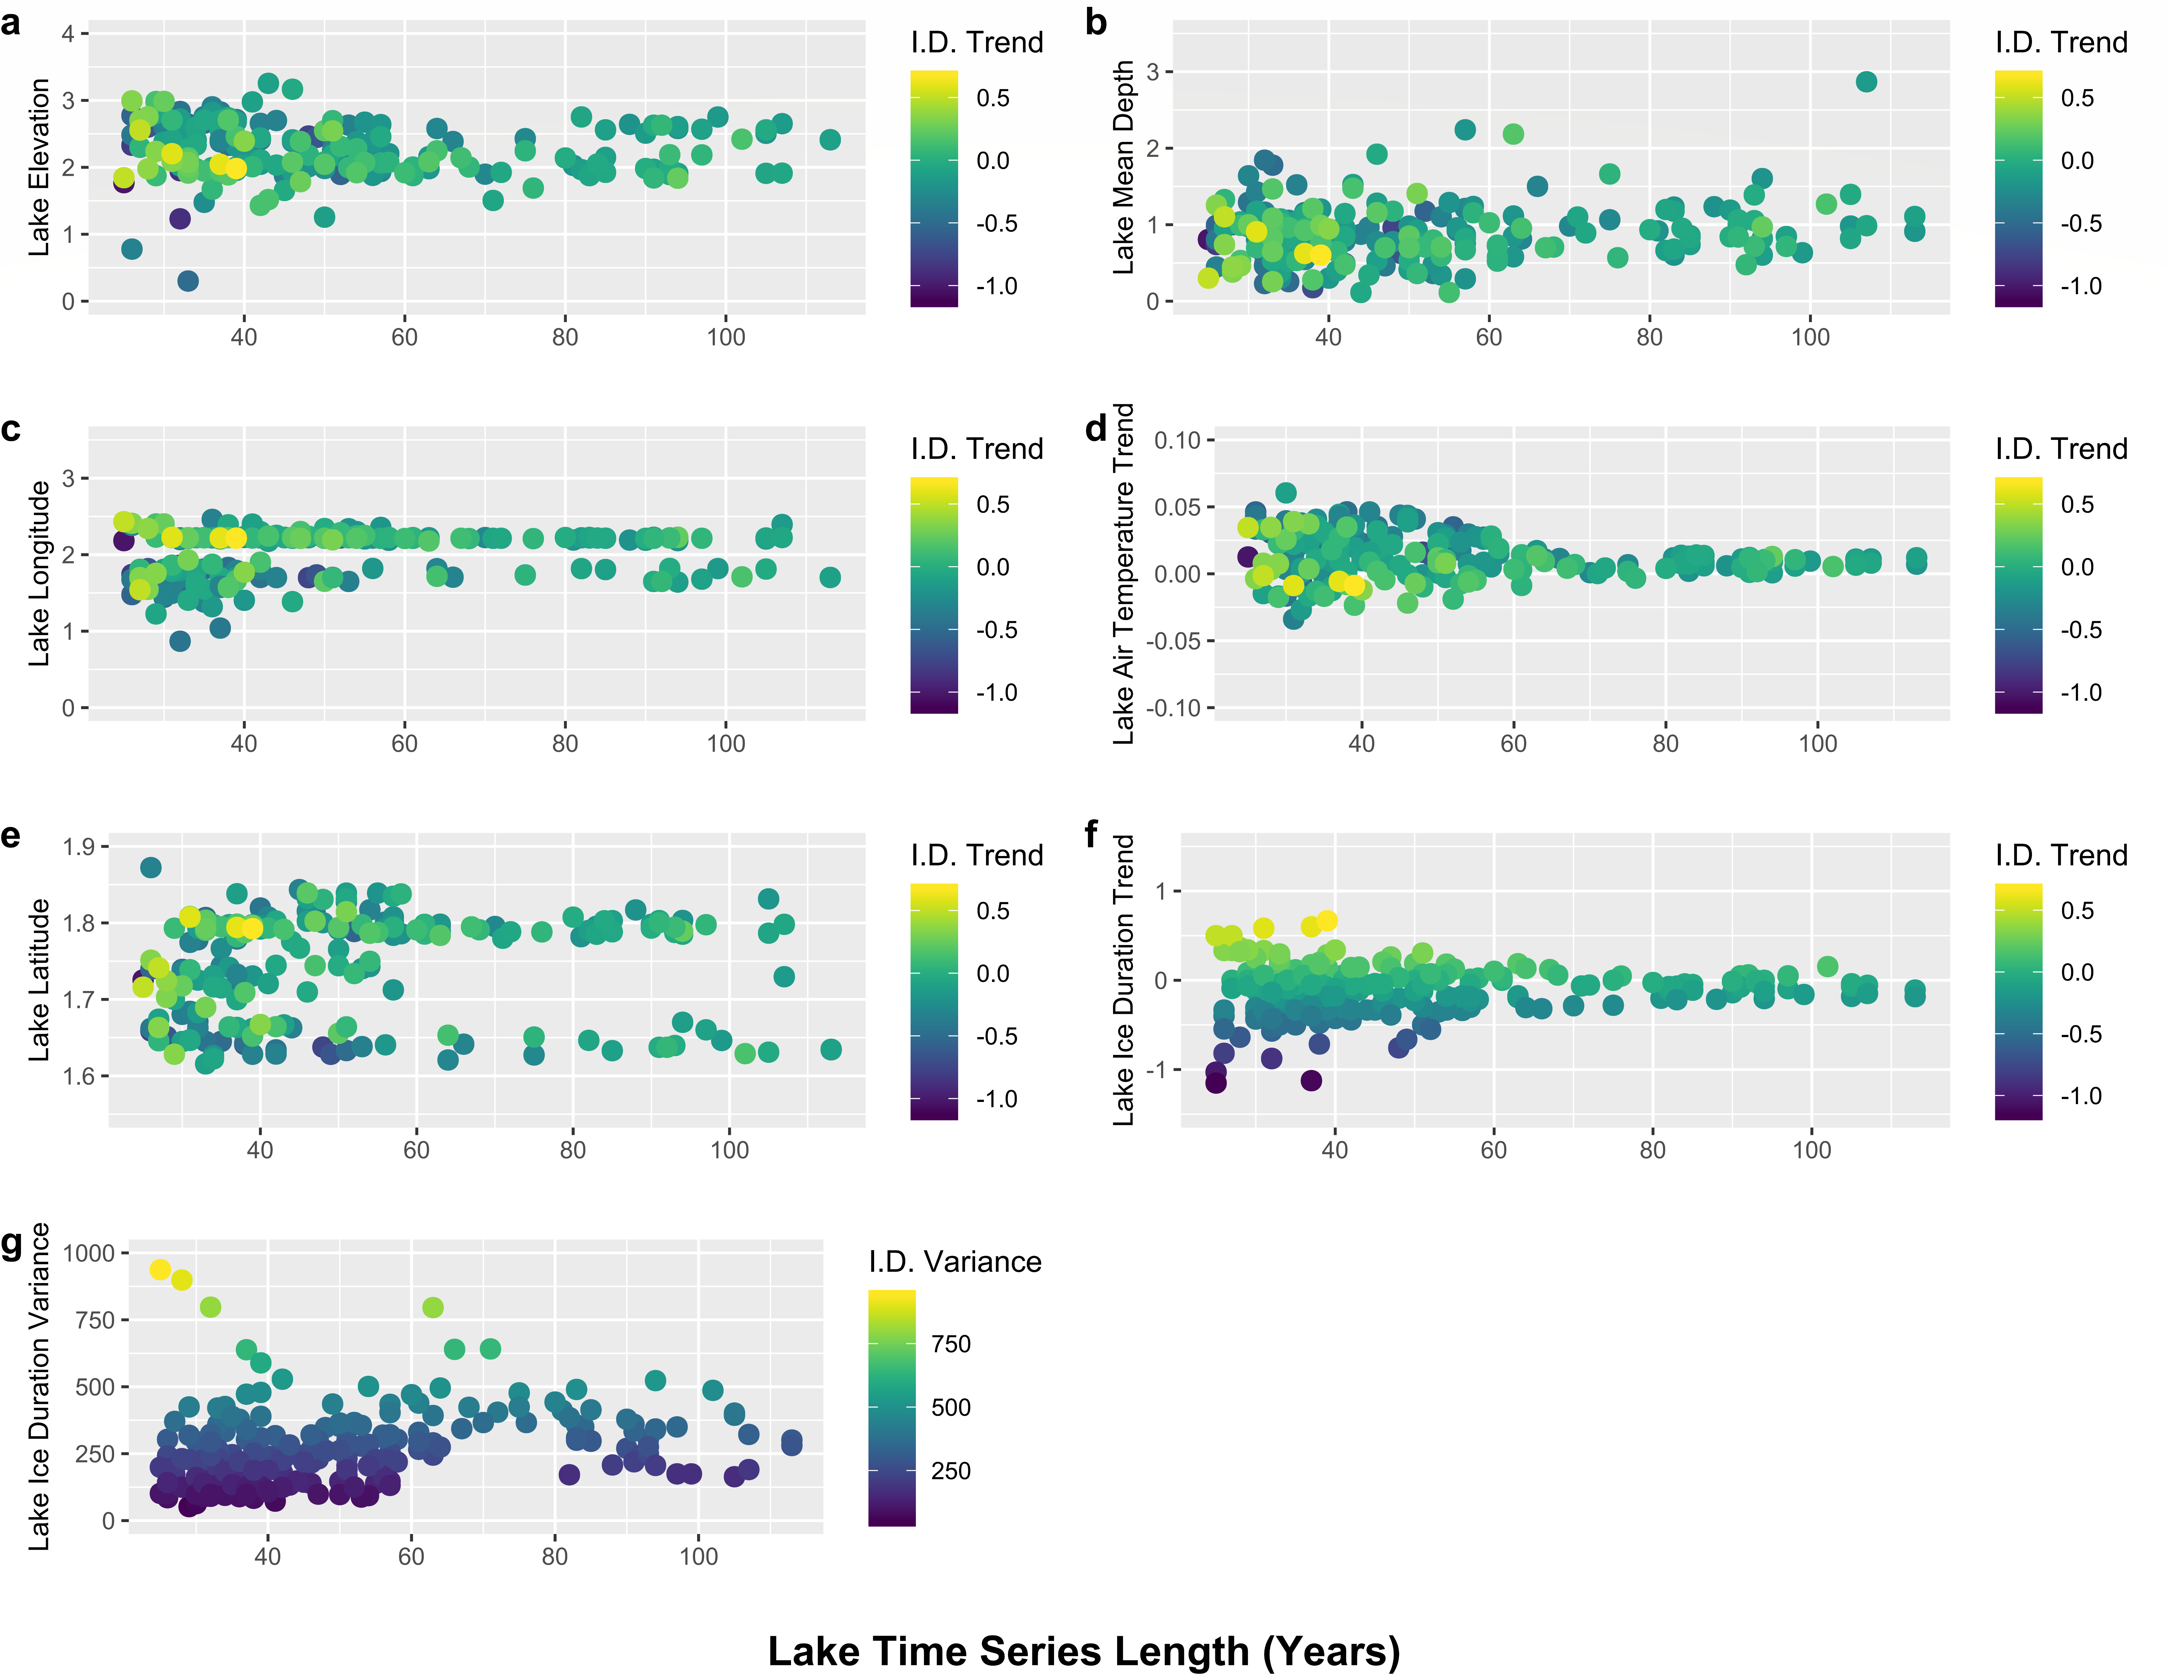

**Figure S2.** The relationship between the length (in years) of lake ice phenology time series data and the predictor variables selected by our multiple linear regression model (a-e) and between time series length and f) lake ice duration trends and g) lake ice duration variance. Colour scales indicate ice duration trend (I. D. Trend) and ice duration variance (I. D. Variance) values.

**Figure S3.** Standardized β coefficients from multiple regression model using only lakes that had overlapping ice duration data from 1950-2000.

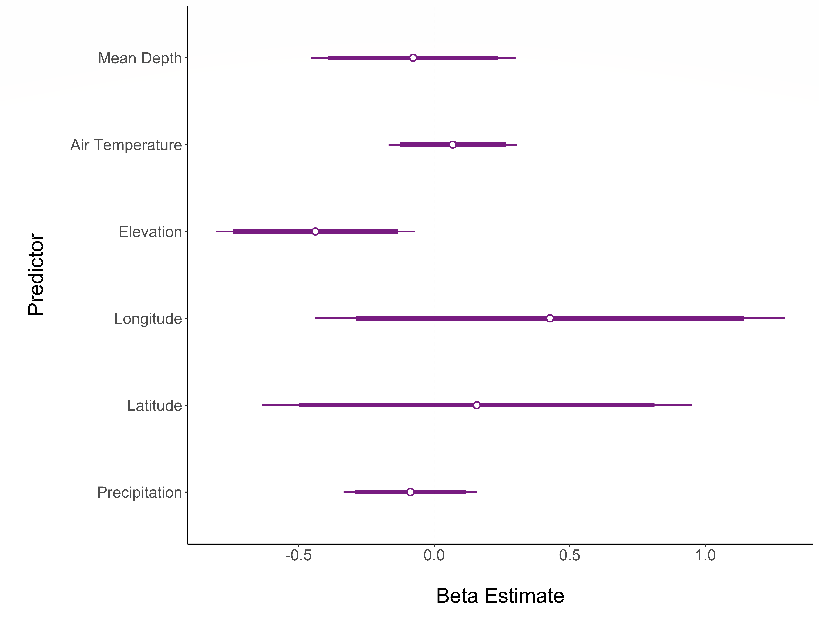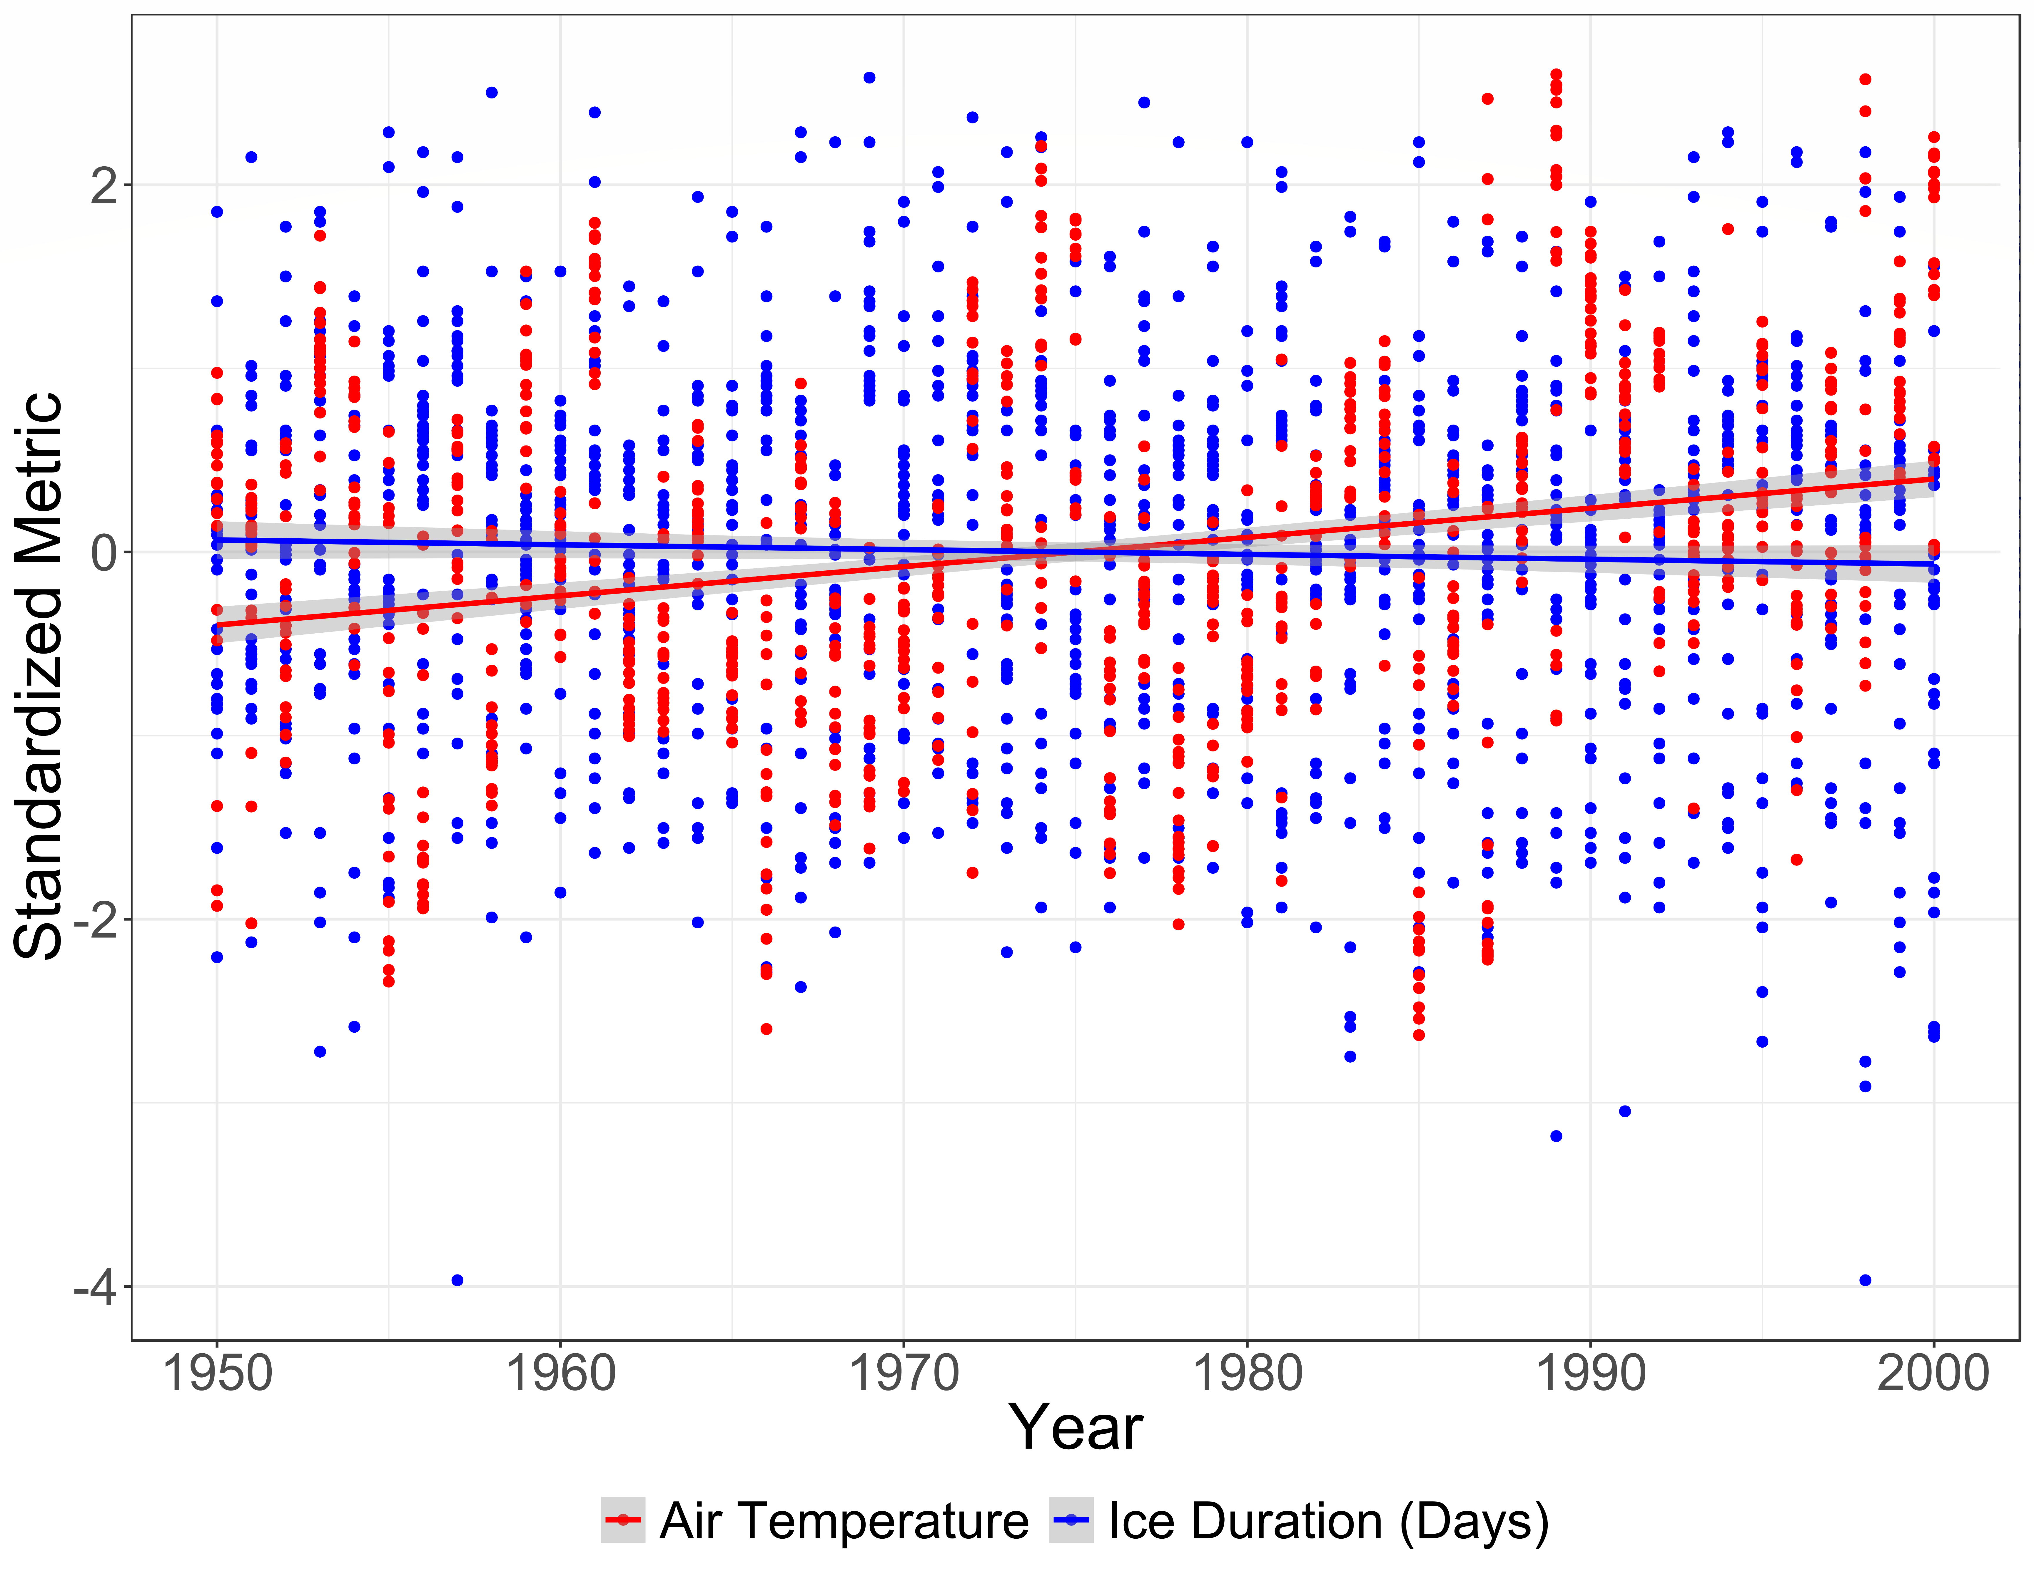

**Figure S4.** Plot illustrating the relationship between standardized (yearly) air temperature anomaly and ice duration (number of days).

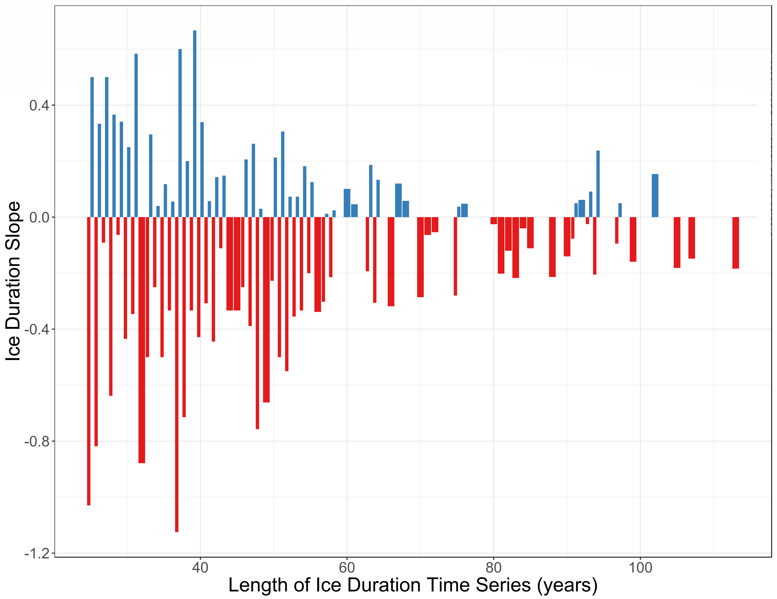

**Figure S5.** The relationship between ice duration trends and the length of lake time series data.

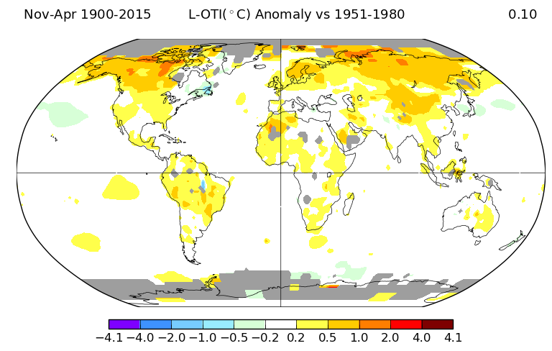**Figure S6.** Global surface air temperature anomalies for the time period of 1900 to 2015 for the northern hemisphere winter months (Nov-Apr). Map created using GISS surface temperature data from NASA (https://data.giss.nasa.gov/gistemp/maps)

|  |  |  |
| --- | --- | --- |
| **Length of ice duration time series** | **Lakes losing ice duration** | **Lakes gaining ice duration** |
| **<50 years** | 88 (69%) | 39 |
| **50-75 years** | 34 (62%) | 21 |
| **76-100 years** | 24 (80%) | 6 |
| **>100 years** | 7 (70%) | 1 |

Table S1. Counts of lakes losing and gaining in ice cover based on the length of their time series.

Table S2. Summary data and ice duration trends results for all northern hemisphere lakes (n=220) used within our analysis. *[attached separately]*